

Presents…

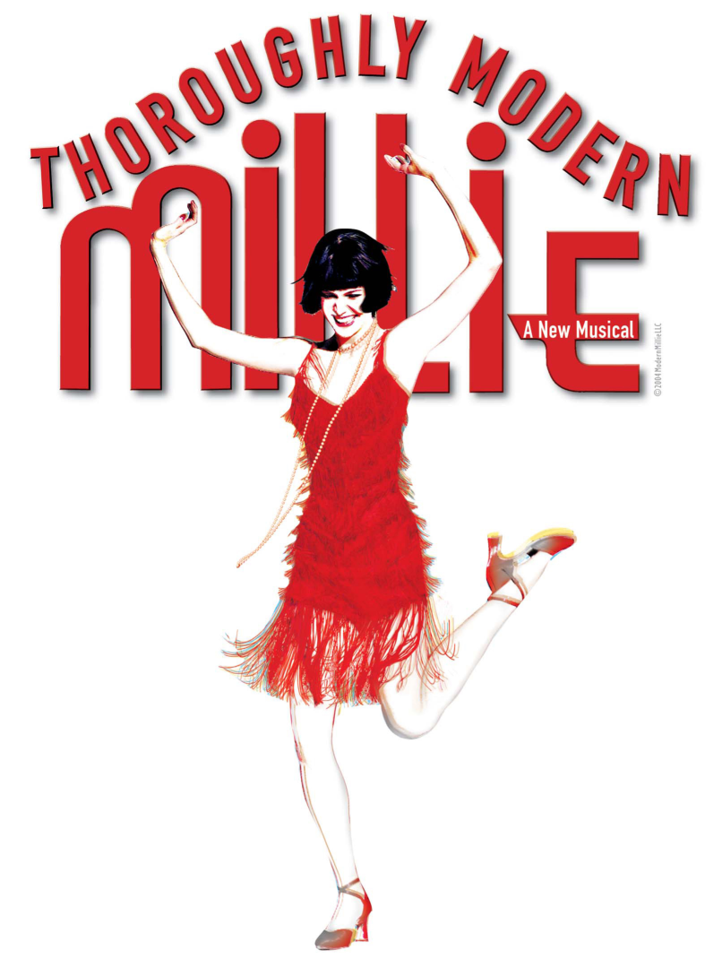

(SAME) AUDITIONS & CALLBACKS...

Auditions will be sometime around early November, 2016. Check back later for more information.

(SAME) PERFORMANCES...

WHEN:

6pm on Sat, Dec 31, 2016

2pm on Sun, Jan 1, 2017

7pm on Sun, Jan 1, 2017

WHERE: The Goppert Theatre at Avila University (11901 S. Wornall Rd, Kansas City, MO 64145)

(SAME) REHEARSALS...

WHEN: December 26 - 31, 2016 from 9am to 6pm daily (some selected leads or specialty dance groups will stay till 9pm)

WHERE: The Goppert Theatre at Avila University

(SAME) NOTE: If you would like to work on a tech crew during this week (building sets, sewing costumes, working with lights and sound, etc.), let us know, and we will do our best to get you plugged in!

ABOUT THE SHOW...

Here's a blurb about Thoroughly Modern Millie... (excerpted from the licensing company's official website.)

The winner of six Tony Awards including Best Musical, Thoroughly Modern Millie was the 2002 season's most awarded new show on Broadway! Based on the 1967 Academy Award-winning film, Thoroughly Modern Millie takes you back to the height of the Jazz Age in New York City, when "moderns" including a flapper named Millie Dillmount were bobbing their hair, raising their hemlines, entering the workforce, and rewriting the rules of love. This high-spirited musical romp is a delightful valentine to the long-standing spirit of New York City and the people who seek to discover themselves there.

Set in New York City in 1922, Thoroughly Modern Millie tells the story of young Millie Dillmount from Kansas who comes to New York in search of a new life for herself. Her grand plan is to find a job as a secretary for a wealthy man and then marry him. However, her plan goes completely awry. The owner of her dingy hotel kidnaps young girls to sell to the Far East; her wealthy boss is slow in proposing marriage; and the man she actually falls in love with doesn't have a dime to his name - or so he tells her.

Filled with frisky flappers, dashing leading men and a dragon-lady of a villainess audiences will love to hate, Thoroughly Modern Millie is a perfectly constructed evening of madcap merriment. From explosive tap numbers to a Fred and Ginger routine on a window ledge this is the perfect show for theatres looking to show off the dance skills of their performers. In Millie Dillmount, musical theatre has found a new heroine for the ages in Thoroughly Modern Millie!

(Button here that says:)

**Show Detailed Plot Synopsis**

We are excited to make this another unforgettable show! Contact us if you wish to be added to the email list to receive the latest updates regarding auditions, rehearsals and performances. We look forward to working with you to create what is bound to be an outstanding production of Thoroughly Modern Millie.

(Then if you click on the button that says: “Show Detailed Plot Synopsis” Please have this appear:)

SYNOPSIS OF THOROUGHLY MODERN MILLIE

http://www.quantalgos.ru/wp-content/uploads/2015/06/warning-sign1.jpgWARNING: SPOILERS AHEADhttp://www.quantalgos.ru/wp-content/uploads/2015/06/warning-sign1.jpg

**Act I**

It's 1922, and Millie Dillmount has just escaped to [New York City](https://en.wikipedia.org/wiki/New_York_City) from [Salina, Kansas](https://en.wikipedia.org/wiki/Salina,_Kansas), and, determined to become a success, tears up her return ticket ("Not for the Life of Me"). Bobbing her hair, she assumes the modern look of a "[flapper](https://en.wikipedia.org/wiki/Flapper)" ("Thoroughly Modern Millie"). But she is quickly mugged on the streets of New York, losing her hat, scarf, purse and shoe. In a panic for someone to help her, she trips bypasser Jimmy Smith, a handsome, carefree young man who makes his way through life on whim and wits, who promptly lectures her on why she needs to head back home: she is just another girl full of false hopes who doesn't belong in the big city. Almost taking his advice, she changes her mind and yells after him, "Who needs a hat? Who needs a purse? And who needs YOU, mister whoever-you-are?!" and soon takes a room at the Hotel Priscilla for Single Women ("Not for the Life of Me [tag]").

A week later, Millie is confronted by the hotel proprietress, the mysterious and sinister Mrs. Meers, an actress turned evil who now works for a [white slavery](https://en.wikipedia.org/wiki/Sexual_slavery) ring in Hong Kong, kidnapping pretty unsuspecting orphan girls and shipping them to the Orient, which she has just done to Millie's hall mate, Ethel Peas. Mrs. Meers declares that Millie "has two minutes to pack, or find her things on the street!" But then Millie meets the wealthy Miss Dorothy, who wants to learn how the poorer half lives ("How the Other Half Lives"), and wants a room in the Hotel Priscilla. Millie, seeing this as a way to get her rent paid, suggests that Miss Dorothy can room with her until she can find her own, but only if Miss Dorothy pays the rent. Mrs. Meers, comes out of her office, saying Millie can get a rent extension, and Miss Dorothy can take the "Nice, sunny room that just become available, right next to Millie's." When Millie asks what happened to her old neighbor, Ethel, Mrs. Meers says she got an acting job in the Orient. Millie and Miss Dorothy then go up to their rooms, tap dancing to get the elevator to start.

In the Hotel Priscilla laundry room, two Chinese immigrants, Ching Ho and Bun Foo, are working for Mrs. Meers to earn enough money to bring their mother from Hong Kong over to the states ("Not for the Life of Me [reprise]").

After researching some of the richest and most eligible bachelors in the world, Millie comes to Sincere Trust not only looking for a job, but also to set her sights on the company's boss, Trevor Graydon III ("The Speed Test"). Her lightning speed stenography easily lands her the job. Meanwhile, Ching Ho attempts to capture Miss Dorothy for Mrs. Meers with a drugged apple but when he sees her, falls in love with her instantly and then wants to save her from Mrs. Meers. Before Dorothy eats the drugged apple, Millie arrives, (Mrs. Meers has to act like she was getting a stain out of the carpet with "Soy Sauce") with the good news that she has found a job and a boss to marry. As the girls rush off to their rooms, Mrs. Meers thinks about how stupid the girls are to never realize she's an evil mastermind trying to ship them to Southeast Asia ("They Don't Know"). To celebrate their success the girls go to a [speakeasy](https://en.wikipedia.org/wiki/Speakeasy), where they meet Jimmy, but the club is raided by the police. While waiting for his release in the jail cell, Jimmy realizes that he loves Millie ("What Do I Need with Love").

Jimmy asks Millie to a party hosted by famous singer Muzzy van Hossmere, and she accepts. Before the party Muzzy sings of her love for New York ("Only in New York"). At the party, Millie spills wine on [Dorothy Parker](https://en.wikipedia.org/wiki/Dorothy_Parker)'s dress, which Millie tries to get out with soy sauce, following Mrs. Meers' example. After the party, Millie explains to Jimmy how she is going to marry Trevor. She also tells him off for being a "skirt chaser" and "womanizer". As they argue, Jimmy suddenly grabs Millie and kisses her, then runs away. Millie realizes that she loves Jimmy ("Jimmy"). Millie returns to the hotel and overhears a conversation between Miss Dorothy and Jimmy, "I really want to tell her, she's my best friend" "You know we can't". Millie sees Jimmy sneaking out of Miss Dorothy's room after what appears to be a late-night tryst; confused and horrified, Millie decides she never wants anything to do with Jimmy ever again.

**Act II**

At Sincere Trust, Millie tells the other stenographers that she is "completely over" Jimmy, then realizes she is still in love; the girls try to convince her to let him go ("Forget About the Boy"). Millie places more conviction into marrying Graydon, but when Dorothy comes to visit Millie at work, Mr. Graydon is immediately smitten with her instead ("Ah! Sweet Mystery of Life"/"Falling in Love with Someone"). The two set up a date together. While Millie is brooding over her lost chances, Jimmy breaks in through the window and asks her to dinner. She initially tells him off but then agrees ("I Turned the Corner"/Falling in Love with Someone" (Reprise)).

Back at the Hotel Priscilla, Mrs. Meers along with Ching Ho and Bun Foo gets ready to drug Miss Dorothy, when Ching Ho refuses because he loves her. Mrs. Meers stops his ranting by reminding them of why they work for her, to raise money to see their mother again. She convinces them to go along with the plan ("Muqin").

Jimmy finally declares his feelings for Millie while washing dishes to pay their tab at Cafe Society while Muzzy is performing her hit ("As Long I'm Here with You"). Millie is confused by her feelings for Jimmy and her desire not to be poor and initially rejects him. She runs to Muzzy, who tells her she's a fool for throwing away true love for the sake of money. She tells the story of how she met her late husband, a supposedly poor but goodhearted man who gave her a green glass necklace. Regardless of his income status, she loved him anyway, and she later realized that her green glass necklace was actually genuine [emerald](https://en.wikipedia.org/wiki/Emerald). Millie reconsiders her feelings and finally realizes that she would rather have a green-glass love with Jimmy ("Gimme, Gimme").

Just as she returns to Jimmy to confess her feelings, they encounter Graydon, who was stood up by Miss Dorothy for their date. He tells Millie and Jimmy that Mrs. Meers told him Miss Dorothy had checked out of the hotel. When Millie recalls that several other tenants had also suddenly "checked out", and that all of them were orphans, Millie, Jimmy, and Graydon realize what Mrs. Meers is doing. They persuade Muzzy to pose as a new orphan in town to trick Mrs. Meers, who takes the bait, is exposed as the mastermind of the slavery ring, and is then taken to the police station. Meanwhile, Ching Ho had already rescued Miss Dorothy and won her heart.

Jimmy proposes to Millie, and, poor as he is, she accepts, "because if it's marriage I've got in mind, love has everything to do with it." Jimmy turns out to be Herbert J. van Hossmere III, Muzzy's stepson, and one of the most eligible bachelors in the world. And Miss Dorothy turns out to be his sister, an heiress named Dorothy Carnegie Mellon Vanderbilt van Hossmere, and (unlike the 1967 film) she ends up not with the dismayed Trevor Graydon, but with Ching Ho. Muzzy reveals that to help Jimmy and Dorothy getting caught by fortune-hunters, she sent them out into the world so that they could find spouses who weren't in it for the money. Both Jimmy and Dorothy had disguised their family name to avoid being found out as society heirs. In a final pairing, Bun Foo joins Graydon's company as a new stenographer after telling Graydon that he can type fifty words a minute. At the very end of the musical, Bun Foo and Ching Ho are once again reunited with their mother.